The 12 BAETE Program Outcomes (POs)
- PO1: Engineering Knowledge – Apply math, science, and engineering fundamentals to solve complex problems.
- PO2: Problem Analysis – Research and analyze complex engineering problems using first principles.
- PO3: Design/Development of Solutions – Design systems or processes meeting specified needs with safety and environmental considerations.
- PO4: Investigation – Conduct investigations of complex problems using research methods and data analysis.
- PO5: Modern Tool Usage – Apply appropriate modern engineering and IT tools with an understanding of limitations.
- PO6: The Engineer and Society – Assess societal, health, safety, legal, and cultural issues and professional responsibilities.
- PO7: Environment and Sustainability – Understand the environmental impact of engineering solutions and sustainable development.
- PO8: Ethics – Apply ethical principles and commit to professional ethics and norms.
- PO9: Individual Work and Teamwork – Function effectively as an individual or team leader in multidisciplinary settings.
- PO10: Communication – Communicate effectively through reports, presentations, and clear instructions.
- PO11: Project Management and Finance – Apply engineering management and economic decision-making in projects.
- PO12: Life-long Learning – Engage in independent, life-long learning amidst technological changes.

Cognitive Domain

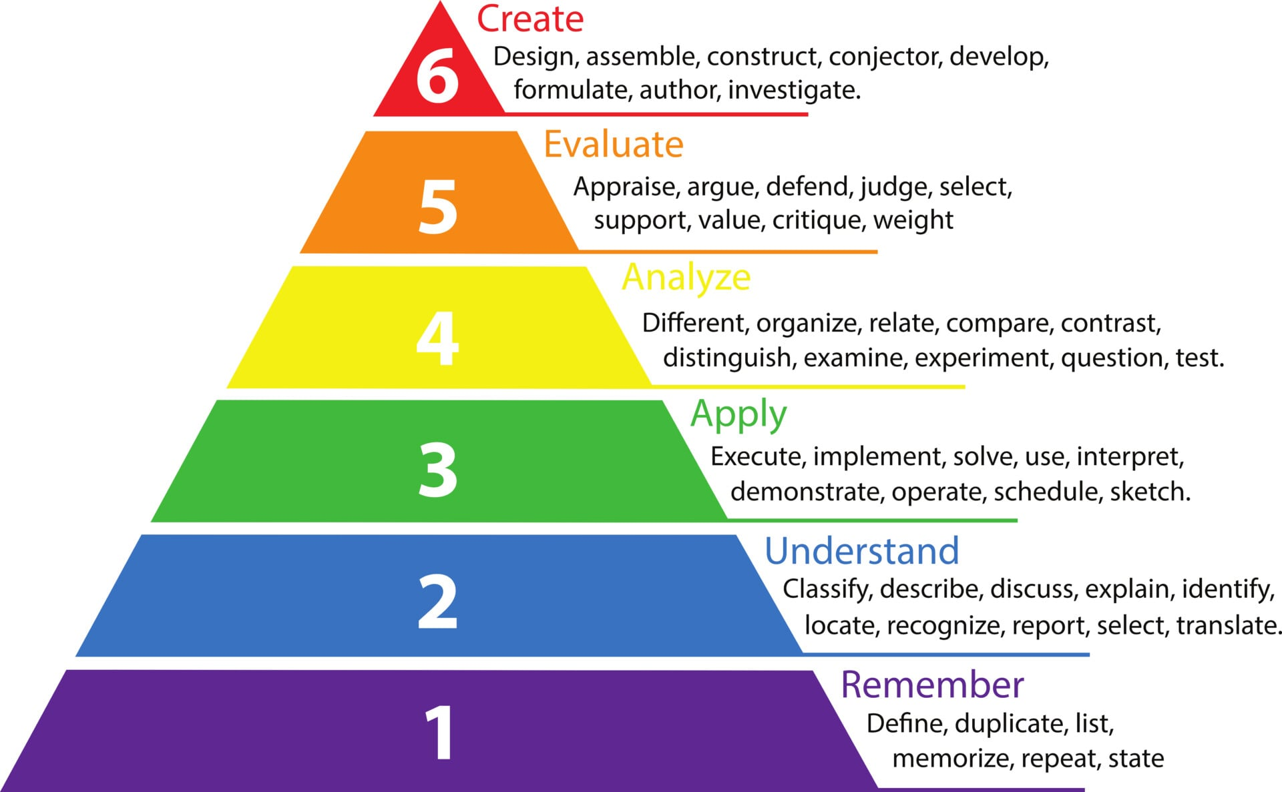

Psychomotor Domain
1. Perception: Using sensory cues to guide physical activity (e.g., smelling burning food and adjusting heat, or watching a coach's form).
2. Set: Readiness to act, including mental, physical, and emotional dispositions that predetermine how one responds to a situation.
3. Guided Response: The early stage of learning a physical skill, relying on imitation, trial, and error.
4. Mechanism: The intermediate stage where learned responses become habitual, and movements are performed with increasing confidence and proficiency.
5. Complex Overt Response: The skillful and smooth performance of complex motor acts with minimal wasted energy and high precision.
6. Adaptation/Origination: The highest level, where skills are so well-developed that an individual can modify movements to fit new situations or create entirely new movement patterns.

Affective Domain
Receiving: The learner is aware of or sensitive to certain stimuli and is willing to listen or pay attention (e.g., listening to others with respect, acknowledging information).
Responding: The learner actively participates, reacts, or complies beyond just being aware, finding satisfaction or engagement in the process (e.g., participating in class discussions, following safety rules).
Valuing: The learner attaches worth, value, or commitment to a specific object, behavior, or phenomenon (e.g., showing sensitivity to cultural differences, demonstrating a belief in democratic processes).
Organizing: The learner brings together different values, resolves conflicts between them, and builds an internally consistent value system (e.g., prioritizing time management, balancing honesty with empathy).
Characterizing (Characterization): The values have taken hold of the individual's behavior for a long time, forming a characteristic lifestyle or personal philosophy (e.g., consistently practicing personal integrity or lifelong responsibility).

